Chapter 5: More HTML5

Contents

HTML Semantic Markup 2

Layout Semantic Markup 2

Header Element 2

Footer Element 3

Nav Element 4

Aside Element 4

Text Semantic Markup 6

# HTML Semantic Markup

It’s important to make sure you use the right tags when making a layout in HTML5. Semantic markup tags describe the information you are displaying on the page. Using them correctly allows you to create layouts that are accessible and descriptive.

## Layout Semantic Markup

The image below shows a typical layout using HTML5 semantic markup. You use items such as the header tag for the header and footer for the footer.

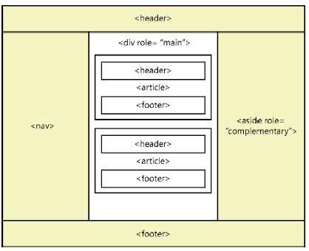

### Header Element



#### Contents of a Header

* Should contain an <h1> to <h6> tag that contains your heading
* Can contain company logos, navigation links
* Can have multiple header elements on a page. For example, each article will have its own header element.

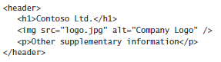

#### Sub Headings

A header can have more than one <h1> to <h6> element. These are often related to each other where you have a big header and an alternative title below. The best way to do this is to use the hgroup wrapper element.

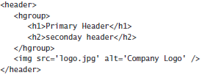

### Footer Element

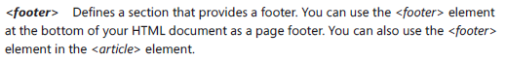

#### Contents of a Footer

* Contains information about the sections it’s in such as:
  + Who wrote it
  + Copyright information
  + Links to related documentation
* Can use it more than once in an HTML document. Often used at the end of an HTML document, section or article.
* Should not be nested inside another footer element.

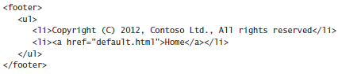

### Nav Element



* You can have many Nav elements in an HTML document
* This is used for your **primary** navigation

### Aside Element



* Used for secondary content in a sidebar

#### Roles

Asides and Divs have a role attribute that should be specified to ensure accessibility. Web Accessible Initiative specifies Accessible Rich Internet Applications suite which defines classes of role attributes. One such class is the landmark class that represents regions of the page intended as navigational landmarks. Descriptions of each of these landmark roles can be found below:

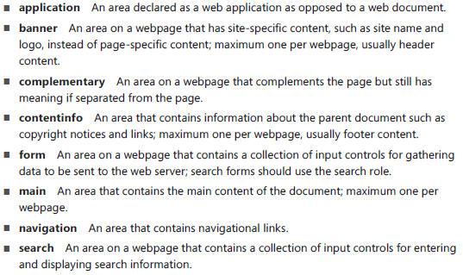

## Annotation Semantic Markup

The elements in the table below can be used to provide semantic meaning to text in your HTML document.

|  |  |  |
| --- | --- | --- |
| **Element** | **Definition/Usage Information** | **Example** |
| <abbr> | Used to indicate abbreviations are being used. |  |
| <addr> | ONLY used for contact information for the author/owner of a document. |  |
| <i> | Represents a span of text that is in an alternate voice or mood or is otherwise offset from the normal prose in a manner indicating a different quality of text, such as a taxonomic designation, a technical term, an idiomatic phrase from another language, a thought or a ship name in Western texts. |  |
| <em> | * Used to designate text you’d pronounce somewhat differently, with emphasis. * Looks the same as the I tag. |  |
| <strong> | * Represents strong important for its contents. * Nested <strong> tags indicate relative importance * Looks the same as a b tag. |  |
| <b> | Represents a span of text to which attention is being drawn for utilitarian purposes without conveying any extra importance and with no implication of an alternate voice or mood. |  |
| <hr> | Provides a thematic break where there is a scene change in a story or to denote a transition to another topic within a section of a reference book. |  |
| <blockquote> | * Block-level element that can contain anything including headers, footers, tables and paragraphs. * Is a sectioning root which means that <h1> to <h6> elements will not render in the document. |  |
| <cite> | * Contains the name of the work being quoted. * Used with blockquote. |  |
| <q> | * Use this inline quotation instead of quotation marks. The browser inserts quotations for you. | This example renders the first quotation by using double quotes and the second quotation by using single quotes. |
| <code> and <samp> | * Documenting code and code examples in your HTML document * <code> indicates the actual code * <samp> indicates the output of the <code> |  |
| <pre> | * The browser typically normalizes the HTML content by removing extra white space, line feeds, and paragraphs from the rendered page. You will often need to provide blocks of text where you want to maintain the existing format when it’s rendered. * Use the <*pre*> element to pre-vent the normalization of the HTML document |  |
| <var> | * Var element denotes a variable in a mathematical equation |  |
| <br /> | * Provides an immediate line break, which continues the document flow on the next line of the browser |  |
| <wbr /> | * Word break element provides an indication to the browser that it may insert a line break at this location. * The browser decides whether it should insert a line break. |  |
| <dfn> | * Denotes the definition of a term * Can contain a title attribute, which contains the term being defined | In this example, the3 <dfn> element is used once fwhere the first instance of VIN is being presented. Inside the <dfn element is an <abbr> element, which provides the meaning of VIN in its title attributes. The use of the <a> element provides a hyperlink to the definition. |
| <figure> | * Unit of content that might have a caption and is referenced from the main document. * Used to denote photos, illustrations, drawings, etc. that are referred to as a unit. * <figcaption> is used to denote an optional caption to the figure. |  |
| <summary> and <details> | * Create collapsible details content under the summary * **ONLY WORKS WITH Google Chrome** |  |
| <s> | * Denotes a strike-out text, text that is no longer valid. |  |
| <u> | * Offsets a span of text without implying a difference of importance. * The default behavior is to underline the text. |  |
| <mark> | * Marks, or highlights, a span of text. |  |
| <ins> | * Indicates inserted text. |  |
| <del> | * Indicates deleted text |  |
| <small> | * Indicates fine print |  |
| <sub> | * Indicates subscript |  |
| <sup> | * Indicates superscript |  |
| <time> | * Denotes a time of day or a date in the text |  |
| <kbd> | * Indicates user input |  |

# HTML Lists

## Ordered List

### Define an ordered list

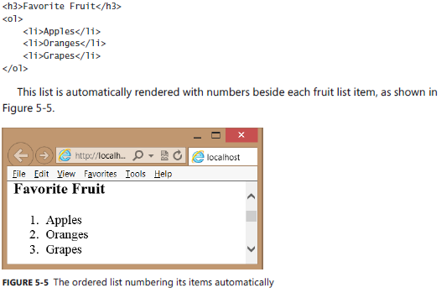

### Ordered list attributes

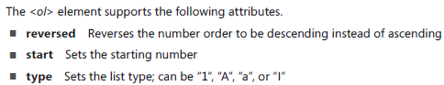

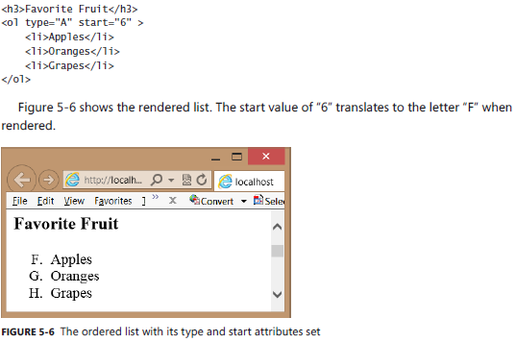

## Unordered List

### Define an unordered list

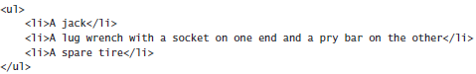

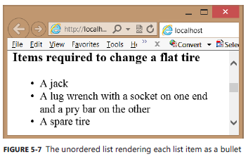

## Description List

### Define a description list

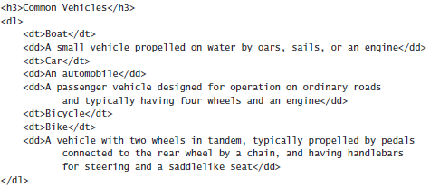

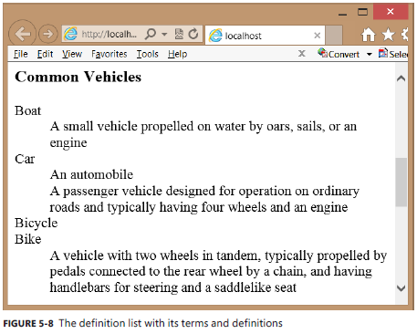

## Custom List Styles

### Custom styles

* **List-style-type** sets the type of bullets that are rendered.
* **List-style-image** sets the bullet to be an image of your choice.
* **Counter-reset:** resets the counter element of a list
* **Content:** Insert a string before or after a list element
* **Counter-increment:** Increment the section counter by 1

### Custom styles example

**Example:** https://jsfiddle.net/k0vm0thm/

**Explanation:**

